**Algebra IA** Name _________________________________ 1.4 – 1.6 Review Date ___________________ Hour ______

Precision and Functions

**Choose the more precise measurement.**

1. 7cm; 7.2cm 2. 35in; 3ft 3. 5.5g; 5.52g 4. 8.231mm; 8.23mm

5. 3m; 302cm 6. 0.5km; 530m 7. 8.5qt; 1.4 gal 8. 4.5hrs; 315min

**Determine the number of significant digits in the measurement.**

9. 251 mm 10. 0.0055 sec 11. 4008 cm 12. 3040 in

13. 0.4500 mi 14. 140.90 ft 15. 1.0040 mm 16. 200 ft

17. 359.24 cm 18. 29.0002 lb 19. 37.0 km 20. 0.0050 sec

**Perform the indicated operation. Write the answer with the correct number of significant digits.**

21. 46.5 m – 12.04 m 22. 7 ft × 10.4 ft 23. 321.62 ft2 ÷ 4.4 ft

24. 0.057 yd + 0.31 yd 25. 6.92 m × 8.12 m 26. 6.4 mi + 2.41 mi

27. 535 kg – 19.32 kg 28. 6.02 cm2 ÷ 12 cm 29. 2.51 sec – 1.51 sec

**Describe and correct the error in the statement.**

30. Susan told her friend Justin that 2.5 hours is a more precise measurement than 145 minutes.

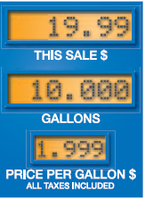31. The input-output table shows the cost of various amounts of regular unleaded gas from the same pump in 2005. Identify the domain and range of the function.

|  |  |  |  |  |
| --- | --- | --- | --- | --- |
| Input (gallons) | 10 | 12 | 13 | 17 |
| Output (dollars) | 19.99 | 23.99 | 25.99 | 33.98 |

**Tell whether the pairing/graph is a function.**

32.

|  |  |
| --- | --- |
| **Input** | **Output** |
| 3 | 9 |
| 4 | 12 |
| 5 | 15 |
| 6 | 18 |

33.

|  |  |
| --- | --- |
| **Input** | **Output** |
| 7 | 5 |
| 10 | 6 |
| 13 | 20 |
| 16 | 6 |

34.

|  |  |
| --- | --- |
| Input | Output |
| 1  2  3  4  3  2  1 | |

35.

|  |  |
| --- | --- |
| **Input** | **Output** |
| 1 | 3 |
| 2 | 4 |
| 1 | 5 |
| 5 | 6 |

36.

|  |  |
| --- | --- |
| **Input** | **Output** |
| 5 | 1 |
| 10 | 1 |
| 15 | 1 |
| 20 | 1 |

37.

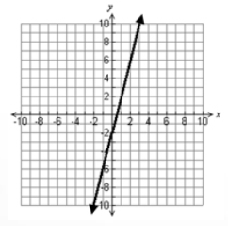

38. 39.

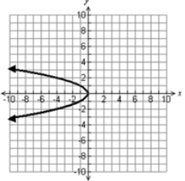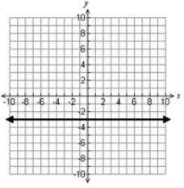

40.

**Write a rule for the function.**

41.

|  |  |  |  |  |
| --- | --- | --- | --- | --- |
| **Input, *x*** | 1 | 2 | 3 | 4 |
| **Output, *y*** | 10 | 11 | 12 | 13 |

42.

|  |  |  |  |  |
| --- | --- | --- | --- | --- |
| **Input, *x*** | 5 | 10 | 15 | 20 |
| **Output, *y*** | 20 | 40 | 60 | 80 |

43**.** The table shows the pay *d* (in dollars) as a function of the number of hours worked *h* with the new minimum wage for Michigan ($8.15/hr as of September 1st, 2014).

|  |  |  |  |  |
| --- | --- | --- | --- | --- |
| **Time (hours)** | 5 | 10 | 15 | 20 |
| **Pay (dollars)** | 40.75 | 81.50 | 122.25 | 163 |

a) Write a rule for this function

b) State the domain and range.

**Graph the ordered pairs.**

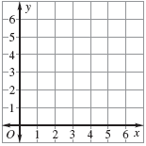44. (2,6), (3,5), (4,4), (5,3), (6,2)

45. (2,2),(8,14),(4,6),(6,10),(3,4)

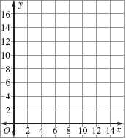

**Complete the input-output table for the function. Identify the domain and range.**

46. *y* = 5*x* + 1

|  |  |  |  |  |
| --- | --- | --- | --- | --- |
| ***X*** | 0 | 1 | 2 | 3 |
| ***Y*** |  |  |  |  |

47. *y* = 2*x* – 1

|  |  |  |  |  |
| --- | --- | --- | --- | --- |
| **X** | 1 | 2 | 3 | 4 |
| **Y** |  |  |  |  |

**Make a table and graph the function**s.

48. y = 3*x* – 2

Domain: 1,2,3,4,5

49. *y* = 10 – 2*x*

Domain: 1, 2, 3, 4, 5

